**Integrating Nuclear and Renewable Energy Sources**

**Pedro Vicente, Adria Peterkin, Joseph Lee**

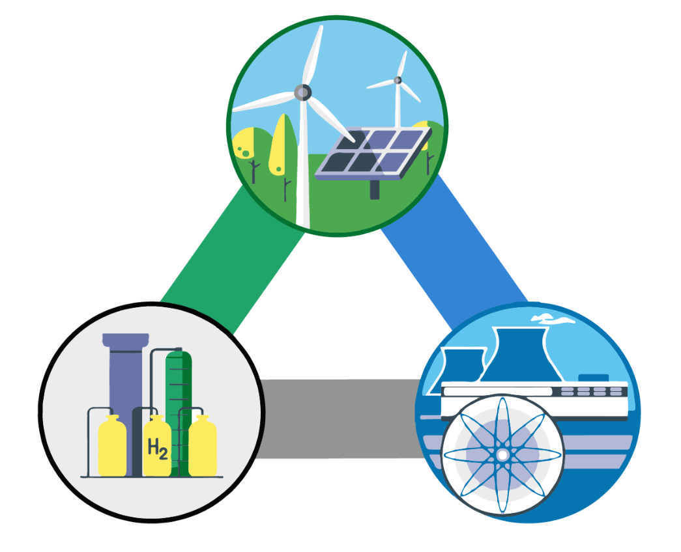

Methods of energy generation are being challenged with an effort to provide production methods that are capable of meeting needs of the present, without endangering the needs of the future. In order to address the decrease in grid stability brought on by the increasing penetration of renewable technologies, the ability to “load follow”, to match the energy output to the demand, is pivotal as it helps prevent oversupplying electricity beyond the demand. The proposed design is a Nuclear-Renewable Hybrid Energy System (NR-HES). This system is comprised of a ThorCon operated molten salt reactor, renewable energy sources, and a 4-step CuCl Hydrogen Production Plant. The economic assessment of a 1 GWe NPP coupled with a 34 ton/day hydrogen production facility results in the ability to produce hydrogen at \$1.66/kg and to reduce the LCOE of the overall system. This shows that instead of relying on Greenhouse gas (GHG) emitting fossil fuels,the same reliability, affordability and flexibility can be achieved. The big economic savings of the nuclear-hydrogen facility leaves space for programs like California’s goals to have 50\% of its energy come from renewable energy by 2020 to be feasible.